**DAILY ONLINE ACTIVITIES SUMMARY**

|  |  |  |  |  |  |  |  |  |
| --- | --- | --- | --- | --- | --- | --- | --- | --- |
| **Date:** | **13/07/2020** | | | | | **Name:** | **Katira Krishna J** | |
| **Sem & Sec** | **8th A** | | | | | **USN:** | **4AL16CS045** | |
| **Online Test Summary** | | | | | | | | |
| **Subject** | | **-** | | | | | | |
| **Max. Marks** | | **-** | | **Score** | | | **-** | |
| **Certification Course Summary** | | | | | | | | |
| **Course** | **Data Science Tools** | | | | | | | |
| **Certificate Provider** | | | **Cognitiveclass.ai** | | **Duration** | | | **5 hours** |
| **Coding Challenges** | | | | | | | | |
| **Problem Statement: Python program to check if a date is valid and print the incremented date if it is** | | | | | | | | |
| **Status: Completed** | | | | | | | | |
| **Uploaded the report in Github** | | | | | **Yes** | | | |
| **If yes Repository name** | | | | | **Krishna_Katira** | | | |
| **Uploaded the report in slack** | | | | | **Yes** | | | |

Online Test Details:

No test conducted

Certification Course Details:

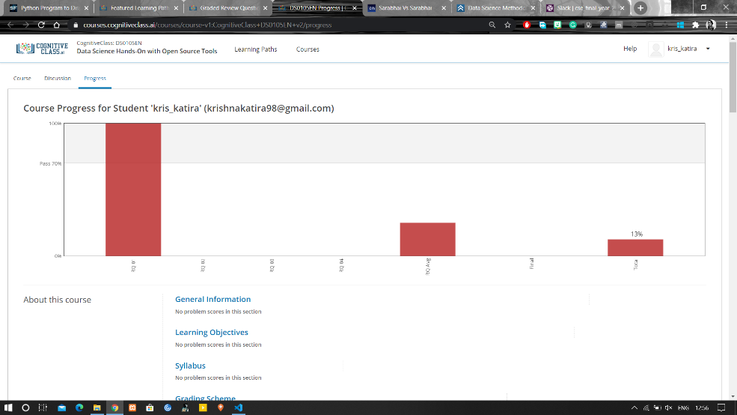

Coding Challenges Details:

**Program:**

date=input("Enter the date: ")

dd,mm,yy=date.split('/')

dd=int(dd)

mm=int(mm)

yy=int(yy)

if(mm==1 or mm==3 or mm==5 or mm==7 or mm==8 or mm==10 or mm==12):

max1=31

elif(mm==4 or mm==6 or mm==9 or mm==11):

max1=30

elif(yy%4==0 and yy%100!=0 or yy%400==0):

max1=29

else:

max1=28

if(mm<1 or mm>12):

print("Date is invalid.")

elif(dd<1 or dd>max1):

print("Date is invalid.")

elif(dd==max1 and mm!=12):

dd=1

mm=mm+1

print("The incremented date is: ",dd,mm,yy)

elif(dd==31 and mm==12):

dd=1

mm=1

yy=yy+1

print("The incremented date is: ",dd,mm,yy)

else:

dd=dd+1

print("The incremented date is: ",dd,mm,yy)